The Islamia University of Bahawalpur

Faculty of computer science

Department of ( IT)

(Project proposal)

E-Commerce Electronic Store

Submitted by:

Aiman Khalid

S25BINFT7M04071

Submitted to:

Dr. Muhammad Asad Ullah

Semester 7(M_1) ADP

March ,20

Introduction:
The e-commerce Electronic website is a user-centric platform designed to facilitate
seamless online

hopping for Electronic. Users can register, search product, manage a shopping cart, and
securely complete orders, and there will be admin panel, admin can handle user accounts,
manage products and add or remove products. The website prioritizes an intuitive user
interface, efficient order processing, and adherence to security and regulatory standards.

With a focus on
reliability and user satisfaction, it aims to provide a visually appealing and responsive
online
shopping experience for Electronic

Electronic Store is an ambitious endeavor to create a sophisticated and user-friendly
ecommerce platform tailored specifically for the Electronic industry. With a focus on
offering a diverse and curated collection of Electronic, this platform aspires to redefine
online shopping experiences by providing a seamless, secure, and enjoyable journey for
users seeking high-quality fashion.

  - Brief

The Electronic e-commerce website is a user-centric platform designed to facilitate
seamless online shopping for Electronic. Users can register, search products, manage a
shopping cart, and securely complete orders, and there will be an admin panel, admin can
handle user accounts, manage products and add or remove products. The website prioritizes
an intuitive user interface, efficient order processing, and adherence to security and
regulatory standards. With a focus on reliability and user satisfaction, it aims to provide a
visually appealing and responsive online shopping experience. Electronic Store is an
ambitious endeavor to create a sophisticated and user-friendly ecommerce platform tailored
specifically, for the Electronic industry. With a focus on offering a diverse and curated
collection of Electronic, this platform aspires to redefine online shopping experiences by
providing a seamless, secure, and enjoyable journey for users seeking high-quality fashion.

1.2 Relevance to Course Modules
I am using HTML/CSS/JS to develop my 'Notes Sharing Site Project'. I studied these
languages in a previous semester, as well as web development.
1.3 Project Background
The fashion industry is constantly evolving, and consumers are increasingly turning to
online platforms for their Electronic needs. This project's background lies in the need for a
user-friendly and comprehensive e-commerce Electronic website.

Traditionally, Electronic shopping has been limited to physical stores. While brick-and-
mortar stores offer a tactile experience, they have limitations in terms of selection,
convenience, and accessibility. This e-commerce Electronic website aims to bridge that gap
by providing:

• Wider Selection: Customers can browse a vast collection of Electronic encompassing
various styles, sizes, and brands, all from the comfort of their homes.

• Convenience: The website allows for 24/7 shopping, eliminating geographical and time
constraints. Easy navigation and filtering tools facilitate a smooth user experience.

• Accessibility
• : The website caters to a wider audience, including those in remote locations or with
limited mobility.

This e-commerce Electronic website is designed to address these limitations and cater to
the changing shopping habits of consumers. It aims to revolutionize the way people shop
for Electronic, offering a convenient, accessible, and diverse online shopping experience

1.5 Analysis from Literature Review (E-Commerce-Website)

The conducted literature review for this e-commerce Electronic website project has
provided valuable insights into current trends and best practices within the online retail
fashion industry. By analyzing scholarly articles, industry reports, and case studies, we
gained a deeper understanding of the key factors influencing customer behavior and
website success. Here's how the identified themes from the library management system
review translate to our project:

1. Importance of User Experience (UX) and User Interface (UI): Website visitors need
a seamless and intuitive experience. Studies emphasize the importance of a user-friendly
interface with clear navigation, efficient search functionalities, and a smooth checkout
process. Additionally, a visually appealing design that showcases products effectively is
crucial for user engagement.

2. Mobile Responsiveness and Accessibility: The review should emphasize the growing
trend of mobile shopping. Our website's design must be responsive and optimized for
mobile devices to cater to this segment of the customer base. Additionally, ensuring
accessibility features for users with disabilities is important for inclusivity.

1.6 Methodology and Software Lifecycle for This Project
The methodology and software lifecycle for a Electronic store refer to the approach that
will be used to manage and develop the project. It includes a set of processes, steps, and
techniques that are used to plan, design, develop, test, deploy and maintain the library
management system. There are different methodologies and software lifecycles that can be
used to develop software projects, and the choice of methodology depends on various
factors, such as project size, complexity, time, and resources available. But here agile
methodology is used.

1.6.1 Rationale behind Selected Methodology
The rationale behind selecting a particular methodology for the E-commerce Electronic
website project is based on several factors, including project requirements, team
capabilities, and industry best practices. The chosen methodology provides a structured
approach to the development and implementation process, ensuring efficient project
management and successful outcomes.

1 Agile Methodology: The Agile methodology has been selected for the Library
Management System project due to its iterative and incremental nature. This methodology
allows for flexibility and adaptability to changing requirements, enabling the project team
to continuously deliver value to stakeholders throughout the development process.

2 User-Centric Approach: This project aims to provide an enhanced user experience and
fulfill the needs and expectations of both library staff and patrons. By adopting an iterative
methodology like Agile, the project team can involve stakeholders in the development
process to gather ongoing feedback, prioritize features, and ensure the system meets them
requirements.

3 Risk Management: The selected methodology also focuses on risk management. By
breaking the development process into smaller iterations, risks can be addressed at different
stages, reducing the impact on the project timeline and overall success.

4 Continuous Improvement: The rationale behind the methodology is to embrace the
philosophy of continuous improvement. Agile methodologies emphasize inspection and
adaptation, enabling the project team to learn from each iteration and make necessary
adjustments. Traditional Electronic stores face limitations in product selection,
accessibility, and convenience. This project aims to address these limitations by developing
a user-friendly e-commerce Electronic website. However, several challenges need to be
overcome for a successful online store:

• Product Presentation and Information Quality:

Problem: Customers cannot physically touch or try on Electronic online.
Challenge: Providing high-quality product images, detailed descriptions, size charts, and fit
guides to compensate for the lack of a physical experience.

• Customer Experience and Navigation:

Problem: Customers may find it difficult to navigate a large online Electronic selection.
Challenge: Developing an intuitive user interface with clear search functionalities, efficient
filtering options, and product categorization to facilitate easy browsing and product
discovery.

• Building Trust and Reducing Purchase Risks:
Problem: Customers hesitate to purchase Electronic online due to concerns about size, fit,
and quality.
Challenge: Implementing features like customer reviews, detailed return policies, secure
payment gateways, and clear size charts to build trust and reduce purchase risks.

2 Problem Definition

The rapid advancement of technology and the shift towards digital marketplaces have
significantly transformed consumer behavior, particularly in the fashion industry.
Traditional brick-and-mortar Electronic stores are increasingly supplemented — and in
some cases, replaced — by online alternatives. However, many existing online Electronic
stores lack user-friendliness, suffer from inefficient order management, or fail to provide a
secure and seamless shopping experience.

The precise problem addressed in this project is the absence of a comprehensive, user-
centric, and efficient online platform specifically tailored for the Electronic retail sector.
Customers often encounter issues such as limited product search capabilities, poor mobile
responsiveness, insecure payment processes, and cumbersome navigation when shopping
for Electronic online. Similarly, store administrators frequently face challenges in
efficiently managing product listings, inventory, customer data, and order processing.

2.1 Problem Statement

In the modern era, online shopping has become an essential part of everyday life. However,
many existing online Electronic stores fail to deliver a seamless, efficient, and user-friendly
experience. Customers often face difficulties such as slow navigation, poor product
organization, limited search functionality, and insecure payment processes. These issues
lead to customer dissatisfaction, abandoned carts, and loss of business opportunities for
retailers.

On the administrative side, managing a Electronic store’s inventory, processing orders, and
maintaining customer profiles can be tedious and inefficient without a properly structured
and intuitive system. Traditional manual processes and outdated online platforms often
result in operational delays, data inconsistencies, and security vulnerabilities.

2.2 Deliverables and Development Requirements

.2.1 Deliverables

The following are the expected deliverables of the Online Electronic Store project:

- Functional E-commerce Website:

A fully operational online Electronic store that allows users to browse products,
search, filter, add items to cart, checkout securely, and manage their accounts.

• Administrator Panel:

A backend system for administrators to manage product listings, monitor
inventory, view customer orders, and handle user account management.

- Database System:

A structured database using to securely store user data, product information, order
details, and transaction records.

• Design Documents:

Detailed Software Requirements Specification (SRS), Software Design
Description (SDD), Use Case Diagrams, Class Diagrams, Data Flow Diagrams,
and State Transition Diagrams.

• Deployment:

Hosting the final version of the website on a cloud-based server such as AWS,
Azure, or a suitable shared hosting provider.

• Testing and Validation Reports:
Documentation of functional, usability, performance, and security testing
outcomes.

• User Manual:
A comprehensive guide explaining how customers and administrators can use the
system effectively.

2.2.2 Development Requirements

• Technologies:

• HTML

• CSS3 (with Bootstrap)
• JavaScript

• Server Requirements:

• Web server (Apache)
• Linux-based server environment (e.g., Ubuntu 20.04) or Windows
Server

• Development Tools:

• Visual Studio Code or any lightweight IDE
• Git for version control
• Browser-based testing (Chrome, Firefox, Safari, Edge

3 Requirement Analysis

The following parts of Software Requirements Specification (SRS) report should be
included in your document in this chapter.

3.1 Use Cases Diagram

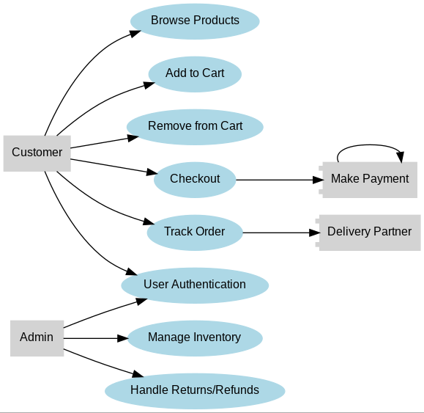

Fig 1: Use Case Diagram

Use case description

The web application enables users to browse a catalog of Electronic, add items to a
shopping cart, and make purchases. The admin oversees the platform by managing
inventory, monitoring sales, and handling user accounts.

Use Case ID:  Use  Name: Case | UC-1  Actor1: User  Actor2: Admin
Description:  Trigger  Preconditions:  Post conditions:  Normal Flow  Alternative Flows:  [Alternative Flow 1  Exceptions:  Business Rules  Assumptions: | 1. Admin  The A dmin is responsible for managing and maintaining the  system to ensure smooth operation  • Role: Handles product listings, orders, and customer management.  • Actions:  ■ Post products for sale.  ■ Manage product listings (add, update, or delete products).  ■ Process and manage customer orders.  ■ Manage customer data such as user profiles and order histories.  2. User  The user interacts with the system to purchase Electronic and  manage their account  • Role: Uses the system to search for products, place orders, and manage their account.  • Actions:  ■ Register as a new user.  ■ Log in to access their account.  ■ Search for Electronic by category, name, or  filters.  ■ Add products to the shopping cart.  ■ Checkout to place an order.  ■ Log out from their account.  Admin: Triggers occur when the admin manages products, orders, or  customers.  User: Triggers occur based on user actions such as account  management, searching, adding products to the cart, or completing  orders.  Admin Preconditions  1. Post Product for Sale  • Admin must be logged in.  • Admin must have product posting permissions.  2. Manage Product Listing  • Admin must be logged in.  • Products must exist in the system.  3. Manage Orders  • Admin must be logged in.  • Orders must be placed by users.  4. Manage Customers  • Admin must be logged in.  • Customer accounts must exist.  User Preconditions  1. Registration  • User is not already registered.  2. Login  • Users must have a registered account.  • User must provide valid credentials.  3. Search for Product  • Products must be available in the system.  4. Add to Cart  • Users must be logged in (if required).  • Product must be in stock.  5. Checkout  • Users must have items in their cart.  • Valid payment and shipping details must be provided.  6. Logout  • Users must be logged in.  Admin Post conditions  1. Post Product for Sale  •Product is added to the product database and displayed  2. Manage Product Listing  • Product information is updated or removed.  3. Manage Orders  • Order status is updated (e.g., processed, shipped).  4. Manage Customers  • Customer data is updated or deleted.  User Post conditions  1. Registration  • User account is created and ready for login.  2. Login  • Users gain access to their account.  3. Search for Product  • Relevant products are displayed.  4. Add to Cart  • Product is added to the shopping cart.  5. Checkout  • Order is placed, payment is processed.  6. Logout  • User is logged out and the session is terminated  Admin Normal Flow  - . Post Product for Sale  Admin logs in → Clicks "Add Product" → Enters  product details → Product is posted and listed.  2. Manage Product Listing  Admin logs in → Selects product → Edits or deletes  product → Updates are saved.  3. Manage Orders  Admin logs in → Views new orders → Updates order  status (e.g., shipped) → Order status is updated.  4. Manage Customers  Admin logs in → Views customer information →  Updates or deletes customer data → Changes are  saved.  User Normal Flow  1. Registration  User opens registration page → Fills in details →  Submits form → Account is created.  2. Login  User opens login page → Enters credentials → Submits  → User is logged in.  .3 Search for Product  User enters search query → System displays matching  products → User selects a product.  4. Add to Cart  User select s product → Clicks "Add to Cart" → Product  is added to cart.  5. Checkout  User reviews cart → Provides payment details →  Confirms order → Order is processed.  6. Logout  User clicks "Logout" → User is logged out and session  ends.  Admin Alternative Flows  – Not in Network]  1. Post Product for Sale (Alternative)  •  If admin fails to provide required product details →  System prompts to complete missing fields → Admin  completes the fields → Product is posted.  If admin fails to provide required product details →  System prompts to complete missing fields → Admin  completes the fields → Product is posted.  2. Manage Product Listing (Alternative)  •  If admin tries to delete a non - existent product →  System displays an error → Admin selects another  product to manage.  3. Manage Orders (Alternative)  •  If order status cannot be updated → System shows an  error message → Admin retries or contacts support.  4. Manage Customers (Alternative)  •  If the admin tries to update a non -e xistent customer  → System shows error → Admin searches for the  correct customer.  User Alternative Flows  1. Registration (Alternative)  •  If a user enters invalid details (e.g., existing emai l) →  System shows an error → User corrects details and  resubmits.  2. Login (Alternative)  •  If the user enters wrong credentials → System shows  an error → User can reset password or try again.  3. Search for Product (Alternative)  •  If no products match search → System displays "No  results found" → User refines search criteria.  4. Add to Cart (Alternative)  •  If the product is out of stock → System shows "Out of  Stock" message → User is prompted to choose  another product.  5. Checkout (Alternative)  •  If payment fails → System shows payment error →  User retries with a different payment method.  6. Logout (Alternative)  •  If session expires → User is automatically logged out  and redirected to the login page.  User Use Case Exceptions  1. Registration: Duplicate email, weak password, network  issues.  2. Login: Incorrect credentials, account locked/inactive.  3. Search Product: No results, invalid filters, load errors.  4. Add to Cart: Out of stock, invalid ID, session timeout.  5. Checkout: Payment failure, address errors, cart inconsistency.  6. Logout: Session issues, unauthorized attempts.  Admin Business Rules  1. Only admins can post, update, or delete product listings.  2. Products must include valid details (name, price, description).  3. Admins can only manage orders and customers within their  role.  4. Deleted products should not affect existing orders.  User Business Rules  1. Users must register with a unique email and strong password.  2. Login is required to add products to the cart or checkout.  3. Search results should match filters and keywords accurately.  4. Items added to the cart must reflect real-time stock availability.  5. Payments must be processed securely and verified before order  confirmation.  Admin Assumptions  1. Admins have valid login credentials.  2. Admins have sufficient permissions for all operations.  3. Products and orders are stored in a reliable database.  4. Admin actions follow company policies.  User Assumptions  1. Users have internet access and a compatible device.  2. Users provide accurate registration and payment details.  3. Stock quantities are updated in real time.  4. Users understand the basic system functionality (e.g., adding to  cart).

Table 1: Use Case

Description
3.2 Functional Requirements

3.2.1 User Management:
• Users should be able to register with unique credentials (email and password).
• The system must validate login credentials for authentication.
• Admins should manage user profiles (view, update, or delete users).

Identifier
USR-001
Title
User Registration and Login
Requirement
User Perspective: "Users should be able to register with
unique credentials (email and password)."
System Perspective: "The system must validate login
credentials during authentication."
Source
Customer Requirements
Enables secure access for users while preventing duplicate
accounts.
Rationale
Each email must be unique in the system.
Business Rule
(if required)
Dependencies
None
Priority
High
Table 2: for user Management

3.2.2 Product Management:
• Admins can post new products with details (name, price, description, stock).
• Admins can update or delete existing product listings.
• Users should search for products by category, name, or filters
Identifier
ADM-002
Title
Product Management
Requirement
Admin Perspective: "Admins can post new products with
details (name, price, description, stock)."
"Admins can update or delete existing products."
Source
Admin Requirements
Rationale
Enables admins to maintain an up-to-date and relevant
product catalog for users.
Stock cannot be set below 0.
Business Rule
(if required)

Dependencies
None
Priority
High

Table 3: For Product Management

3.2.3 Cart Management:

• Users can add, update, or remove items from their cart.
• The system must calculate the total cost, including applicable taxes and
shipping.
• Secure payment processing must be integrated into the checkout process.
USR-003

Identifier

Title
Cart Management
Require
ment
User Perspective: "Users can add, update, or remove items
from their cart."
System Perspective: "The cart must update in real-time with
changes to items."
Source
Customer Requirements
Rational
e
Provides a seamless shopping experience, enabling users to
prepare for checkout easily.
Cart items must not exceed available stock.
Business
Rule (if
Required

)

USR-002
Dependencies

Priority
High
Table 4: For Cart Management

Table 4: For Cart Management
3.2.4 Session Management:
• Users and admins must log out securely to terminate sessions.
• The system should automatically log out inactive sessions after a set timeout
period.
Identifier
SEC-001
Title
Session Management
Requireme
nt
User Perspective: "Users and admins must log out securely
to terminate sessions."
System Perspective: "The system automatically logs out
inactive sessions after a timeout period."
Source
Security Requirements
Rationale
Enhances platform security by reducing the risk of
unauthorized session access.
Timeout period is set to 10 minutes.
Business
Rule (if
required)
USR-001
Dependencies

Priority
High
Table 5: For Session Management

3.2.5. Reporting and Analytics:
• Admins can generate reports for product sales, customer data, and order
trends.
• The system should provide dashboard insights into real-time system
performance.

3.2.5. Reporting and Analytics:
• Admins can generate reports for product sales, customer data, and order
trends.
• The system should provide dashboard insights into real-time system
performance.

3.3 Non-Functional Requirements
3.3.1 Scalability
The system should be scalable to support growth in the number of users, products, and
transactions. It must allow for easy upgrades to handle increased demand. The
architecture should support horizontal scaling (adding more servers) and vertical
scaling (upgrading system resources). Database structure and APIs should be designed
with scalability in mind. Cloud deployment options may also be considered for
dynamic scalability.

3.3.2 Security Requirements
Security is critical for protecting user credentials, payment details, and personal data.
All sensitive information should be stored using encryption techniques. Secure
authentication mechanisms (e.g., hashed passwords, CAPTCHA) must be used. Data
transmission must occur over HTTPS. The system should be protected against
common attacks such as injection, XSS, and CSRF. Regular audits and role-based
access control (RBAC) must be implemented.
3.3.3 Availability
The system must be available 24/7 with minimal downtime. Scheduled maintenance
windows should be planned in advance and communicated to users. Use of redundant

systems and backup servers is recommended for high availability. Monitoring tools
should alert administrators in case of failures. Cloud infrastructure or load balancers
may be used to ensure uninterrupted service.
3.3.4 Usability
The application must have an intuitive and user-friendly interface. Navigation should
be simple and clear, even for non-technical users. Forms should have proper
validations and tooltips. Font, colors, and layout should be aesthetically pleasing and
consistent across pages. Mobile responsiveness is essential to ensure usability on all
devices. Users should be able to complete tasks efficiently with minimal training.

3.3.5 Maintainability
The system should be easy to maintain, update, and debug. Code should be modular
and well-documented to support future enhancements. Use of version control (e.g.,
Git) is essential. Developers should follow consistent coding standards. Logs and
monitoring tools should help detect issues early. The database should be designed to
allow safe updates without affecting existing data.
3.3.6 Compliance
The system must comply with relevant legal, regulatory, and industry standards. This
includes data protection laws (such as GDPR or local privacy regulations). E-
commerce and payment systems must follow PCI DSS standards. Proper user consent
and terms of service agreements must be in place. Audit trails and logs should be
maintained for accountability. Compliance with accessibility standards (e.g., WCAG)
should also be considered.

4 Design and Architecture

The following parts of Software Design Description (SDD) report should be included in this
chapter.

4.1 System Architecture

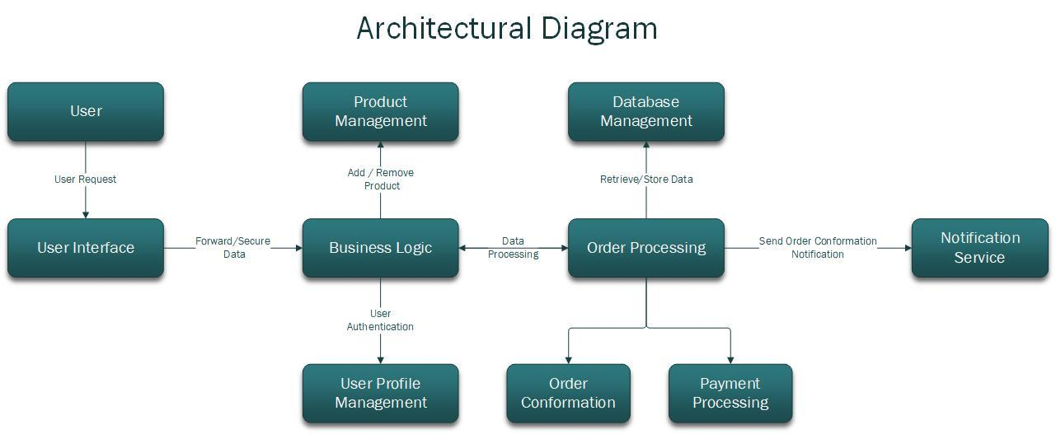

Fig 2: System Architecture
1. User Interface (UI):
• Presents the web interface to users.
• Handles user interactions and communicates requests to the backend.
2. Business Logic:
• Core functionality managing the product catalog, inventory, orders, and user profiles.
• Validates user inputs and enforces business rules.
3. Database Management:
• Stores and manages data related to products, inventory, orders, and user profiles.
• Supports efficient retrieval and update operations.

4. Order Processing:
• Processes customer orders.
• Communicates with business logic for inventory and order updates.

5. Product Management:

• Manages products and communicates with business logic for catalog updates.
6. User Profile Management:
• Handles user authentication, registration, and profile updates.

• Communicates with business logic for user-related actions.
Module Relationships:
• UI communicates with Business Logic for user requests.
• Business Logic communicates with the Database for data operations.
• Order Processing, Product Management, and User Profile Management interact with
Business Logic for specific tasks.

Subsystem Connections:
• Well-defined connections through APIs or service contracts.
• Modular design allows for updates, replacements, and additions without affecting the
entire system.

4.2 Data Representation
User:
• Represents a general user of the Electronic store platform.
Attributes:
• User Id (int): Unique identifier for each user.
• Name (string): User's name.
• Email (string): User's email address.
• Password (string): User's login password.
• Last login (string):User’s last Login info.
Operations:
• Authenticate (credentials): Registration, login and Authenticates the user during the
login process.
Customer:
• Represents a customer interacting with the Electronic store platform.
Inherits from User.
Attributes:
• Browse Products: Allows the customer to browse available Electronic products.
• Update profile (details): Allows the customer to update their profile information.
• Billing Address (details): Add Customer’s billing Address.
Operations:
• Inherits attributes from the User class.

Shopping-Cart:
• Manages the items selected by the customer for purchase.
Attributes:
• userId(int): Unique identifier for each user.
• productId(int): Unique identifier for each product
Operations:
• AddToCart (product): Adds a selected product to the shopping cart.
• removeItem (product): Removes a product from the cart.
• Checkout (): Initiates the checkout process.
Orders:
• Represents a customer's order.
Attributes:
• Order ID (int): Unique identifier for each order.
• Customer (Customer): Reference to the customer placing the order.
• Product List (List of Product): List of products included in the order.

• Total Price (float): Total amount for the order.
Operations:

• Process Payment(payment Details): Handles the payment process for the order.

• Place Order (): proceed the order for confirmation.

• Cancel Order(): cancel the order process.

• Confirm Order (): confirmation from the customer to be shipped to billing address.

Order-Details:
• Represents the details of each product within an order.

Attributes:

• User Id (int): Unique identifier for each user.

• OrderId (int): Unique identifier for each order detail.

• Product (Product): Reference to the product in the order.

• Quantity (int): Quantity of the product in the order.

• Subtotal (float): Subtotal for the specific product in the order.

Operations:

• Cancel Order (): cancel the order process

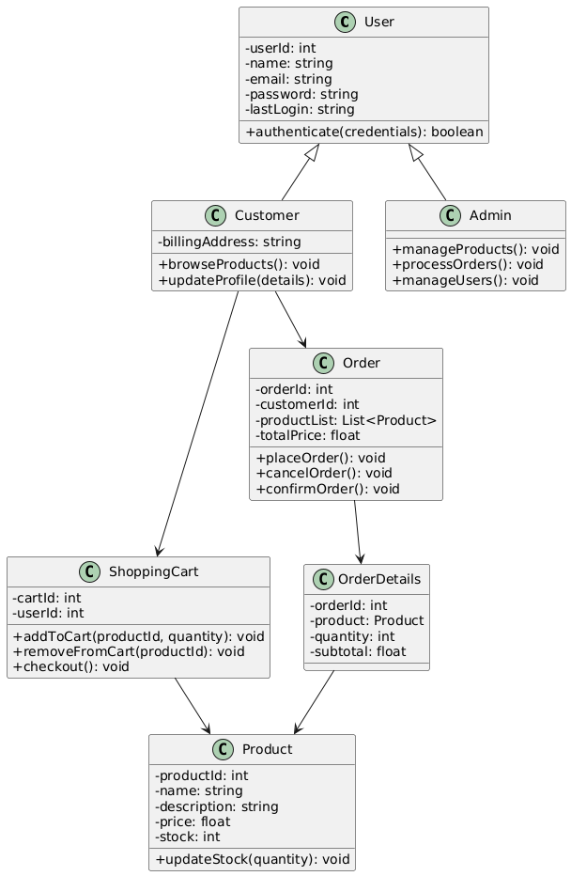
Fig 3: Data representation

4.4 Design Models
The applicable models may include:
• Sequence Diagram
• State Transition Diagram
• Data Flow Diagram
4.4.1 Sequence Diagram:
• Customer: The person interacting with the Electronic store online platform.
• Online Electronic store: Represents the website or platform for purchasing
Electronic s.
• Shopping Cart: Manages the availability ofElectronic items in the store.
• Admin: Handles the process of order processing for Electronic purchases.
Sequence of Events:
• The customer visits the Electronic store's online platform.
• The platform requests the product list from the Electronic inventory.
• The platform displays the available Electronic products to the customer.
• The customer adds selected Electronic items to their cart.
• The platform checks the availability of the chosen items with the inventory system.
• Upon confirmation of item availability, the platform informs the customer that the
items have been added to the cart.
• The customer proceeds to checkout for the Electronic items.
• The platform initiates the payment process through the Admin for Electronic
purchases.
• The admin confirms the order for Electronics items.
• Finally, the platform sends an order confirmation to the customer for the Electronic
purchase.

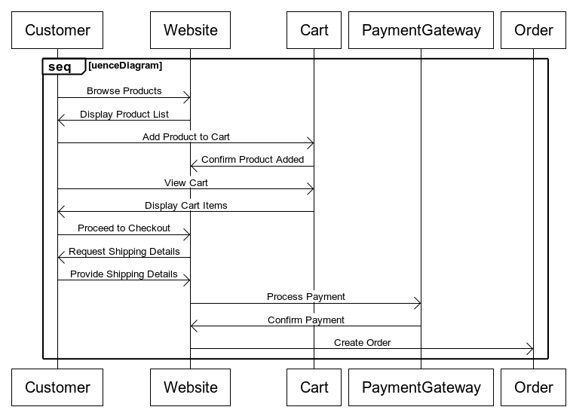

Fig 5: Sequence diagram
4.4.2 State Transition Diagram:
1. User Not Logged In (Initial State):
Description: This is the initial state when the user is not logged into the Electronic store
platform.
Transitions:
If the user chooses to log in, transition to the "User Logged In" state.
If the user decides to browse products without logging in, transition to the "Browsing
Products (Guest)" state.
2. Browsing Products (Guest):
Description: In this state, a non-logged-in user can browse the product catalog as a guest.

Transitions:
If the user decides to log in, transition to the "User logged In" state.
If the user adds items to the cart, transition to the "Shopping Cart (Guest)" state.
3. User Logged In:
Description: The user is successfully logged into the platform.
Transitions:
If the user starts browsing products, transition to the "Browsing Products (Logged In)" state.
If the user accesses their profile, transition to the "User Profile Management" state.
4. Browsing Products (Logged In):
Description: A logged-in user is browsing the product catalog.
Transitions:
If the user adds items to the cart, transition to the "Shopping Cart (Logged In)" state.
If the user proceeds to the checkout, transition to the "Placing Order" state.
5. Placing Order:
Description: The user is in the process of placing an order.
Transitions:
If the user completes the order, transition to the "Order Confirmation" state.
If the user cancels the order, transition back to the previous state.

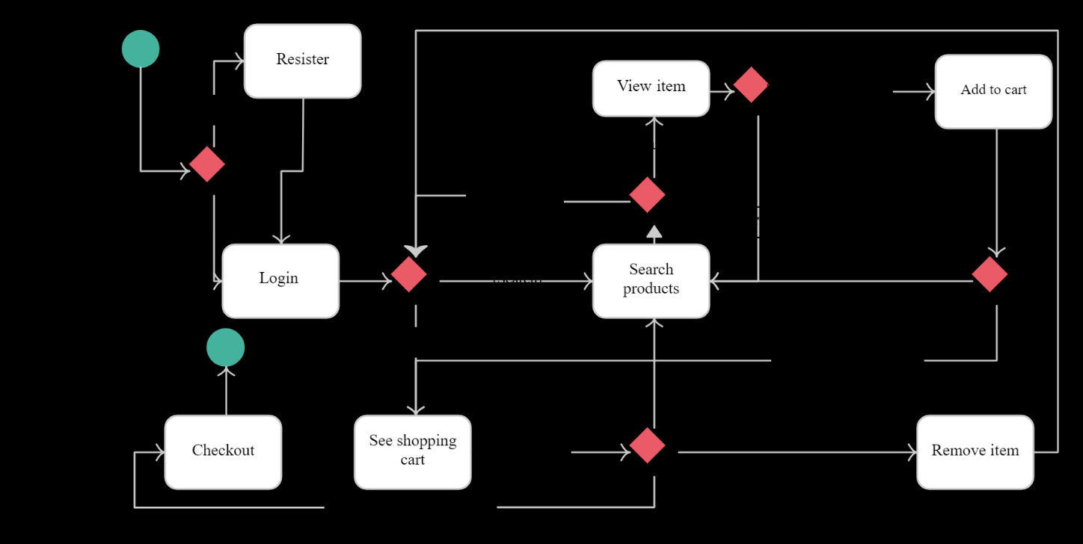

.
Fig 6: Transition Diagram
4.4.3Data Flow Diagram:
Data Flows:
Customer submits registration details.
User Registration and Authentication process validates and stores user information in
the User Database.
Customer browses the Product Catalog.
Product Catalog Management updates product information.
Customer places an order, triggering the Order Processing process.
Order Processing updates the Order Database, processes payments, and updates
inventory.
Customer updates their user profile, triggering the User Profile Management process.

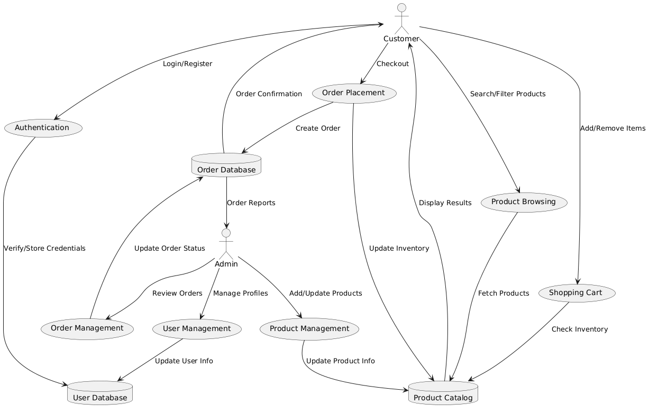
Fig 7 : Data Flow Diagram

5 Implementation
The implementation of the Online Electronic Store follows a modular and layered
architecture, ensuring separation of concerns and maintainability. Each module is
responsible for a specific aspect of the system's overall functionality, with components
interacting through clearly defined interfaces. The Agile methodology was used to develop
the system in iterative cycles, enabling regular testing, feedback integration, and feature
refinement..
5.1 Algorithm
5.1.1 User Registration and Authentication Algorithm
Purpose:
To securely register new users and authenticate existing users for system access.
Pseudo code:

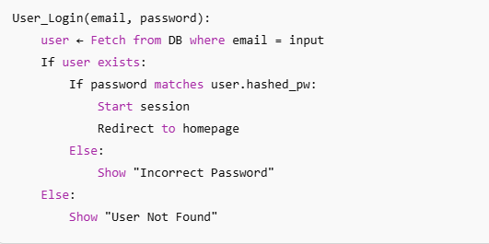

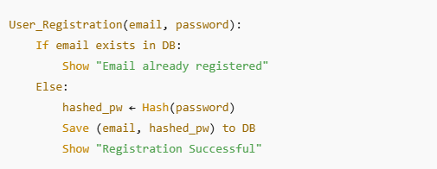

5.1.2 Product Search and Filter Algorithm

Purpose:
To allow users to search and filter Electronic based on specific keywords or
categories.
Pseudo code:

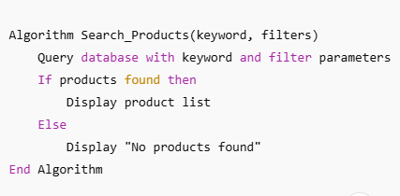

5.1.3 Shopping Cart Management Algorithm
Purpose:
To manage adding, updating, and removing products in the shopping cart.
Pseudo code:
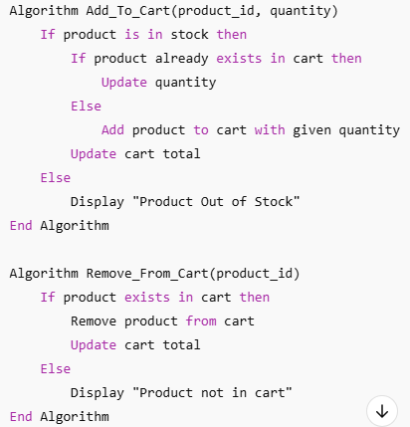
5.1.4 Order Placement and Payment Algorithm

Purpose:
To validate cart, process payment securely, and create an order.
Pseudocode:
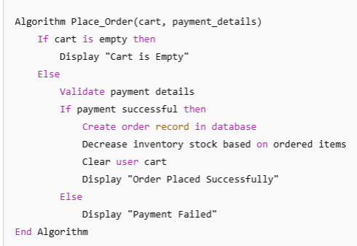

5.1.5 Admin Product Management Algorithm
Purpose:
To enable admins to add, update, or delete products in the catalog.
Pseudocode:
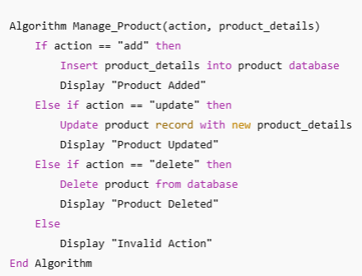

5.3 User Interface
The user interface (UI) of the Online Electronic Store is designed to deliver a clean,
intuitive, and responsive experience. Both customers and administrators interact with
a simple yet powerful design aimed at making navigation, shopping, and management
tasks easy and efficient. The interface follows modern usability principles, ensuring
consistency, feedback, and accessibility.

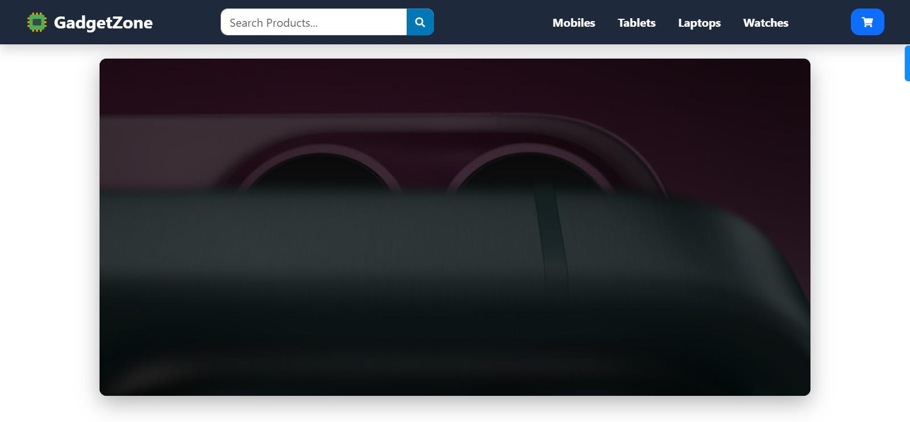

Upon accessing the website, users are greeted with a welcoming Home Page
branded".
At the top, a fixed navigation bar provides quick access to essential sections such as
Home, Category, Product, and Contact. A search bar is prominently placed on the
right, allowing users to quickly search for products by name or keywords.
Next to the search bar, a shopping cart icon and a Login link are displayed, enabling
users to view their cart contents and log into their accounts easily.
Beneath the navigation bar, a hero section features a large banner image showcasing a
fashion model, accompanied by promotional text such as:
The design employs a light, neutral color background with black text, ensuring high
readability and a modern aesthetic. Overall, the Home Page is visually engaging and
aims to quickly direct users towards browsing and purchasing products.

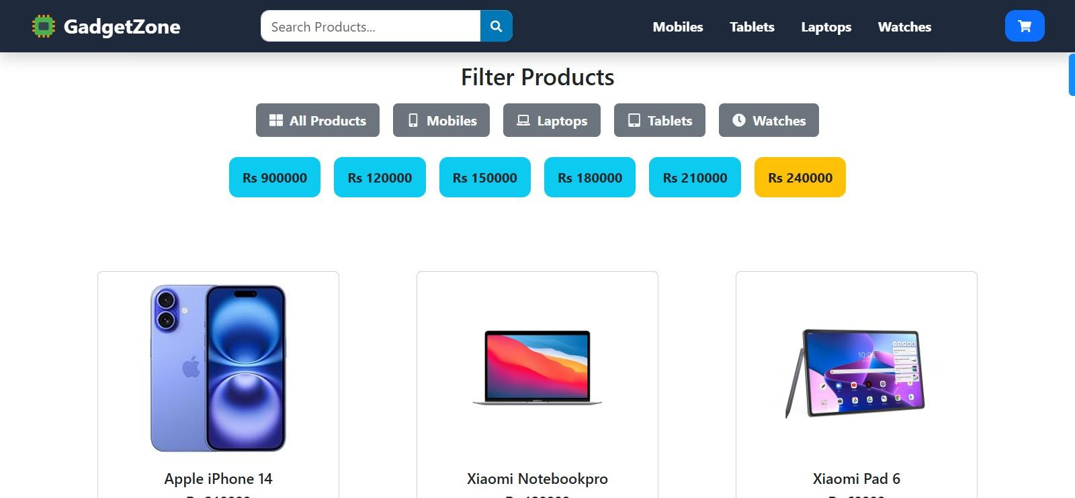

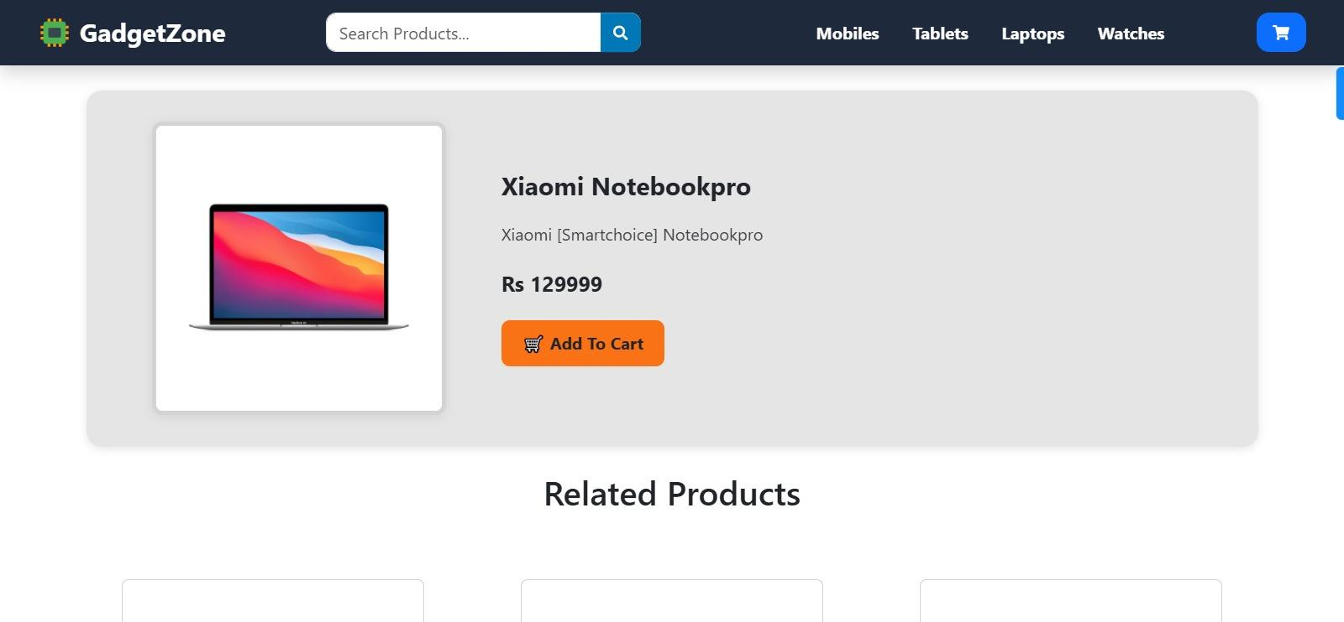

5.3.4 Add to cart

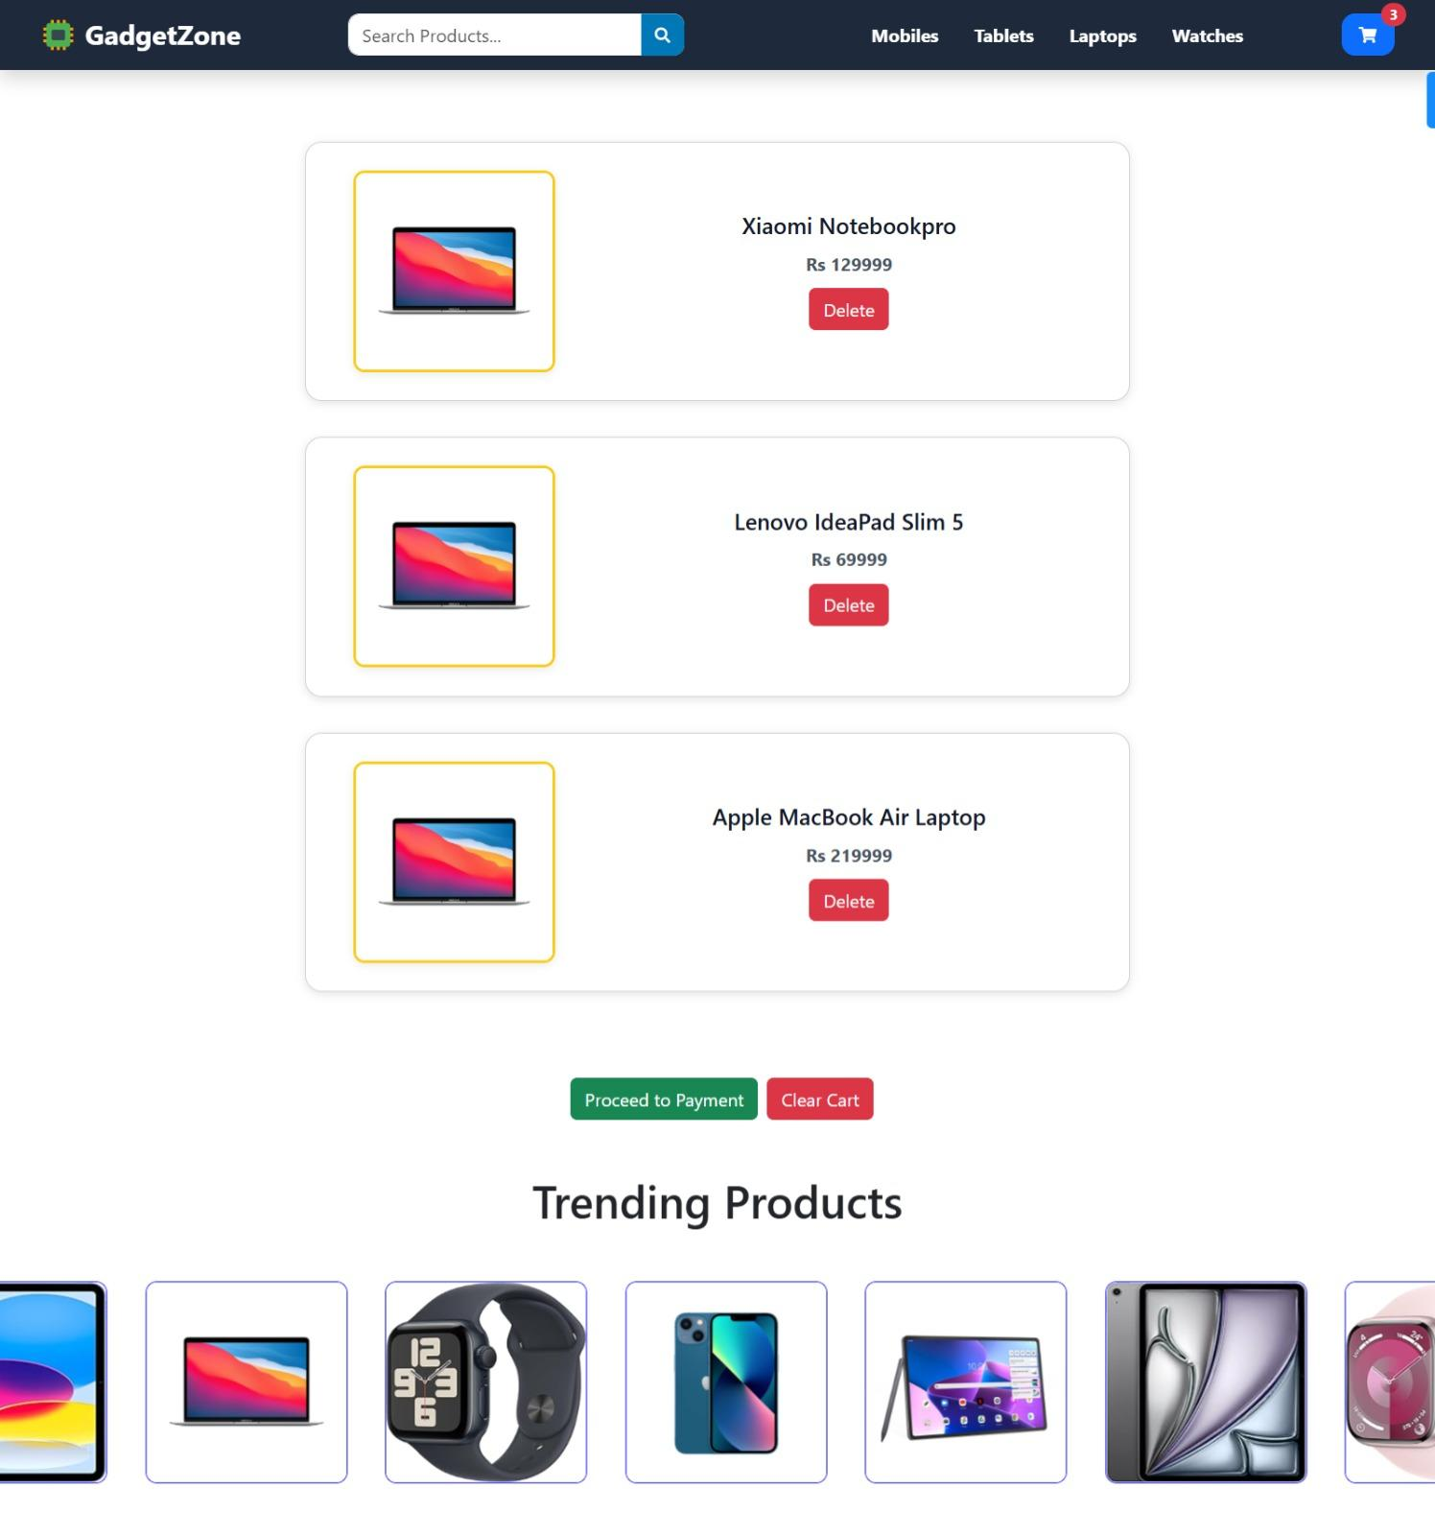

6 Testing and Evaluation
This chapter may include the following sections. (Students are required to perform the testing
both manually and automated).
6.1 Manual Testing
6.1.1 System testing
Once the system has been successfully developed, testing has to be performed to ensure that
the system working as intended. This is also to check that the system meets the requirements
stated earlier. Besides that, system testing will help in finding the errors that may be hidden
from the user. There are few types of testing which includes the unit testing, functional
testing and integration testing. The testing must be completed before it is being deploy for
user to use.

6.1.2 Unit Testing

Unit Testing 1: Login as FYP Committee
Testing Objective: To ensure the login form is working correctly

No | Test case/Test script | Attribute and value | Expected result | Result
1 | Verify user login after  click on the „Login‟  button on login form  with correct input data | Username:  Aiman  Khalid @g  mail.com  Password:  Ahmad@123 | Successfully log  into the main page  of the system. | pass
2 | Invalid password | aiman@12/ wrong password | ―Incorrect‖  Password error | Pass

Unit Testing 2: Edit Profile
Testing Objective: To ensure the edit profile form is working properly.

NO | Test case/Test script | Attribute and value | Expected result | RESULT
1 | Update User Information | First name  Last Name  Email  Password  Phone | Successfully updated  the profile | Pass

6.1.3 Functional Testing

The functional testing will take place after the unit testing. In this functional testing, the
functionality of each of the module is tested. This is to ensure that the system produced meets
the specifications and requirements.

Functional Testing 1: Login with different roles
Objective: To ensure that the correct page with the correct navigation bar is loaded.

NO | Test case/Test script | Attribute  And  Value | Expected result | Result
1 | Admin Login | Username:  Aimankhalid5123 @g mail.com  Password: ahmad@123 | Admin dashboard  Should be login | pass
2 | User login | User@gmail.com/user  123 | User dashboard will be  limited Access | pass

6.1.4 Integration Testing

NO | Test case \test script | Attribute and value | Expected result | Result
1 | Login as User | Username:  Aimankhalid5123 @g mail.com  Password: ahmad@123 | Login  and the  Committee  successful  FYP  page  with its navigation  bar is loaded and  in the view profile  page | pass
2  3 | Upload Products for  Project  View Products list |  | Product  successfully  uploaded  return to the  upload  page.  Product list is  updated  .  The list of products  shown on the  screen | Pass  pass

6.2 Automated Testing:

Tools used:

Tool Name | Tool Description | Applied on [list of  related test cases / FR /  NFR] | Results
Selenium IDE | Browser-based automation  tool for recording and  playing back UI tests. | Automated Login Testing  (FR-Login), Navigation Tests  (FR-User Profile, FR-Product  Browsing | pass
Unit | Unit testing framework for  applications. | Backend Validation for User  Registration, Login (FR-User  Management), Cart  Operations (FR-Cart) | Pass
Postman | API testing tool used to  automate and validate server  responses. | Testing server-side APIs like  Login Request, Product Fetch  Request (FR-Server  Communication) | pass

7 Conclusion and Future Work
7.1 Conclusion
This document has served as a comprehensive guide for developing an e-commerce
Electronic website. We've explored the entire process, from defining the project's
vision and data representation to outlining the implementation details and testing
strategies.
Key Achievements:
• Established a clear vision for a user-friendly and feature-rich e-commerce Electronic
website, catering to both sellers and buyers.
• Developed a data model using UML class diagrams to represent entities like products,
users, orders, and their relationships within the system.
• Described the user journey and back-end processes, providing a roadmap for smooth
website operation.
• Discussed the implementation process, including technology stack selection,
development stages, and database design considerations.
• Emphasized the importance of comprehensive testing, encompassing both manual and
automated approaches, to guarantee website functionality, usability, and security.
7.2 Future Work
While this project lays a solid foundation, there's immense potential for further
development and expansion. Here are some exciting possibilities to explore:
• Advanced Features:
Implement a user wish list functionality to allow customers to save products for later
purchase.
Integrate a product recommendation system based on user browsing behavior and
purchase history to personalize the shopping experience.
Enable product reviews and ratings to enhance customer trust and provide valuable
insights for product selection.
Develop a loyalty program to reward repeat customers and foster brand loyalty.
• Scalability and Performance Optimization:
Implement load balancing and caching techniques to ensure smooth website
performance under high traffic loads.
Design the website for scalability to accommodate future growth in product offerings
and customer base. Consider cloud-based hosting solutions for increased flexibility
and scalability.
• Mobile Optimization:
Enhance the website's responsiveness and user interface for optimal viewing
and interaction on mobile devices.
Develop a dedicated mobile app to provide a seamless shopping experience on
smartphones and tablets.

References
1.
2.
[1] A. B. Author and C. D. Author, ―Title of paper, ‖ Journal Name, vol. 10, no.
3, pp. 123–130, Mar. 2020.
Mozilla, ―Hashing Passwords,‖ MDN Web Docs. [Online]. Available:
https://developer.mozilla.org/en-US/docs/Web/Security/Password_hashing
[Accessed: Apr. 28, 2025].
Documentation, ―Password Hashing — Manual,‖ [Online]. Available:
https://www.php.net/manual/en/function.password-hash.php [Accessed: Apr. 28,
2025].
MDN Web Docs, ―JavaScript Guide,‖ Mozilla Developer Network. [Online].
3.
4.
Available:
https://developer.mozilla.org/en-US/docs/Web/JavaScript/Guide
5.
[Accessed: Apr. 28, 2025].
Shopify, ―What is an Online Store? Definition and Examples,‖ Shopify.
[Online]. Available: https://www.shopify.com/encyclopedia/online-store
[Accessed: Apr. 28, 2025].

